**Design Document**

Kaloyan Aleksiev – Individual Project

Northern Eagle Deliveries

|  |
| --- |
| **Date : 17.01.2021** |
| **Version : 4.0** |
| **State : Finished** |
| **Author : Kaloyan Aleksiev** |

# 1. Higher lever architecture diagram

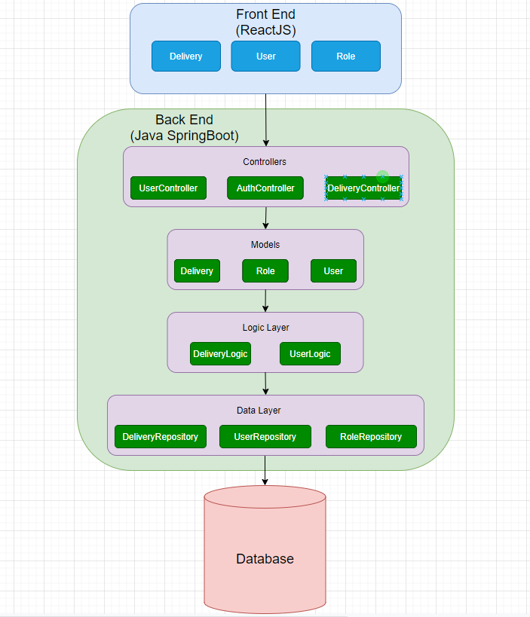

I chose to use this design because it guarantees that the SOLID principles of object oriented programming will be respected and I think the architecture is suitable for the project. Of course, some of the classes that take care of the security and the authentication are not included in this diagram.

# 2. Back-End framework choice

My back-end framework of choice is SpringBoot. The reason I went with it instead of Jersey is because I feel it is more beginner-friendly with all of its useful documentation (Spring Documentation, 2020) and guides, thus making it easier for me to understand how it works and to create everything that I will need for the project.



# 3. Front-End framework choice

The framework I chose to work with for my front-end is ReactJS. After doing the research and comparison between React (React Documentation, 2020), Angular (Angular Documentation, 2020) and Vue (Vue Documentation, 2020) along with my group project teammates, I decided that React would be the most interesting one to begin with. Thanks to it being the most used one out of the three, it has countless articles/tutorials about it on the web, making it very easy to find information in case I get stuck. So far I have been enjoying it.

# 4. References

*Angular Documentation. (2020, October). Retrieved from Angular: https://angular.io/*

*React Documentation. (2020, October). Retrieved from ReactJS: https://reactjs.org/*

*Spring Documentation. (2020, September). Retrieved from Spring IO: https://spring.io/*

*Vue Documentation. (2020, October). Retrieved from VueJS: https://vuejs.org/*

Contents

1. Higher lever architecture diagram 2

2. Back-End framework choice 3

3. Front-End framework choice 3

4. References 4